
SCHOOL OF COMPUTER SCIENCE AND ENGINEERING
SCHOOL OF BIOTECHNOLOGY AND BIOMOLECULAR SCIENCES

INDUSTRIAL TRAINING

Ricky Chang (rycc903)
3077696
ricky.chang@student.unsw.edu.au
mahleresolution@gmail.com
0405 536 990

Report on industrial training with
Macquarie University Biotechnology Research Institute,
Bioinformatics Group

Submitted as a requirement for the degree
Bachelor of Engineering (Bioinformatics)

Supervisor: Shoba Ranganathan (Professor of Bioinformatics)
Period of Employment: 11/12/2006 – 16/03/2007

ACKNOWLEDGEMENTS

I would like to thank Professor Shoba Ranganathan for giving me an opportunity with the Bioinformatics Group. You have been extremely patient and understanding with me.

Next, I would like to thank Durgaprasad Bollina. You have been very kind in sharing and explaining this interesting project with me.

CONTENTS

INTRODUCTION 1
PROJECT 2
2nd stage input parser API 3
Graph API 5
Event classification 6
JSP servlet 7
TRAINING 9
IT RELEVANCE 10
STUDIES 10
FUTURE PLANS 10
CONCLUSION 12
REFERENCES 13

INTRODUCTION

I worked in the Bioinformatics Group of the Macquarie University Biotechnology Research Institute. The Bioinformatics Group is headed by my supervisor, Professor Shoba Ranganathan, and has its own dedicated laboratory, with 6 machines for both research and hosting of various internal and external services, as needed.

The group has a degree of autonomy in deciding its research direction, but due to the nature of bioinformatics requirements for high-confidence primary research data as input, much of what is done relies on experimental results from collaborations both within and outside of the parent institute.

PROJECT

My time at Macquarie University was spent largely on a project described as “Event-Based Graphing Service” (abbreviated as EBGS) [5]. It is currently an unpublished work, but it is a continuation and expansion of the Drosophila melanogaster Exon Database which my supervisor Professor Ranganathan worked on in a previous collaboration with members of the National University of Singapore, where she still holds an adjunct professor position.

The basic methodology is similar to DEDB, but the following reasons warranted the creation of a new code base:

- Inclusion of multiple new organisms
- Changes in project requirements
- Major modifications of web resource APIs
- Higher Throughput
- Code ownership

For the purposes of this IT report, technical specification and implementation can be discussed in detail, while scientific methodology can only be mentioned in brief.

I focused my efforts on several aspects of this project, including parsing input, graph output, web user features and interface, with the set timeframe of 60 working days in mind. I obtained the requirements from this project from research papers that described the functionality of DEDB, as well as presentations for the proposed functionality of EBGS.

I programmed in 2 Java APIs, namely JDBC and JSP, and utilized principles of object oriented programming. Throughout this time, I consistently made program documentation and kept a learning journal of challenges I faced, and how I overcame them.

Web data assembler
2nd stage input parser API
RAW
mySQL
Graph
mySQL
Generate graph
JSP web interface
Location
Mac Pro

iMac web server
Figure 1. A schematic view of the project [5].

2nd stage input parser API

This parser API resided on a Mac Pro. This task occupied 2 weeks. The parser API needed to fulfill the following requirements:

- Retrieve RAW mySQL data
- Parse RAW data into transcript objects for access by other classes
- Retrieve available graphs from mySQL upon user’s JSP request
- Request retrieval of unavailable graphs from web data assembler class

The web data assembly class, residing on the Mac Pro, was already written when I started on the project. What it did was to access raw scientific results from the ENSEMBL Genome Browser web server [4] and assemble the relevant fields into our own raw data format. This was deposited into a mySQL relation (hence known as RAW, also residing on the Mac Pro).

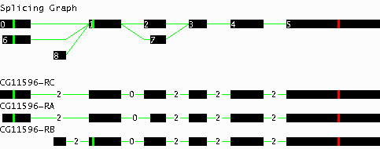
Figure 2. Example of a transcript [3]. The “Splicing Graph” consists of all alternative transcripts combined together to provide an overview of exon usage as well as splicing events within the particular transcript. Below, the individual alternative transcripts (different ‘splicings’) are displayed as separate graphs. CG11596-RC is the main transcript and CG11596-RA, CG11596-RB are the alternative transcripts within the transcript object.

My 1st subtask within the 2nd stage input parser API was to access RAW data, and map out the transcripts. The rows in RAW represent transcript exons, and are shown as black bars in Figure 2. Given non-sequential, basic properties such as start and end positions, I wrote an algorithm to arrange the exons by position, frequency and size.

At this point, it made sense to me to encapsulate the transcripts and exons into objects. It was a very natural representation of the data, and it allowed other users to manipulate the parsed transcripts without any knowledge of the RAW input. I wrote “Transcript.class” to describe this newly created object and its fields. Within “Transcript.class” I devised an inner class called “Exon”, which defined the individual exons that made up each transcript. To me, this was a very elegant solution, as it abstracted the RAW data from transcript objects. I was able to create higher level classes independent from underlying RAW data format changes.

When an instance of “Transcript.class” was created, an ArrayList() was initialized. I made use of ArrayList.add() to append sorted Exons() to the transcript object. The inbuilt functions of ArrayList() allowed me to query the transcript object in a multitude of ways, e.g. transcript ID, transcript length, number of transcript exons, listing out alternative transcripts, etc.

With transcripts objects created, they were ready for graph visualization and event classification.

Graph API

This graph API resided on the Mac Pro. This task occupied 3 weeks. The graph API needed to fulfill the following requirements:

- Query transcript objects’ properties to draw JPEG graph
- Insert graph into GRAPH mySQL relation
- Infer transcript classification and insert it into CLASS mySQL relation

To take into account different transcript lengths, I defined a scale that would resize transcripts based on a transcript’s total length, so that it would not exceed 800px in length. I encountered as many as 8 alternative transcripts, so height of the JPEG was variable to accommodate the differing numbers.

The graph drawing aspect of this class was easy to code, due to the Java AWT API. Debugging, although time consuming, was straightforward due to abundance of test data. I tested simple to complex cases in 40 sample transcripts. The main issues faced in testing were the correct positioning of exons and their connecting introns (lines in green in Figure 2), as well as overcrowding of the graph when there were more than 5 alternative transcripts. Towards the end of testing, I was confident that the graph drawing functionality was correct. Upon creation, the graphs were inserted into a mySQL relation called GRAPH.

Event classification

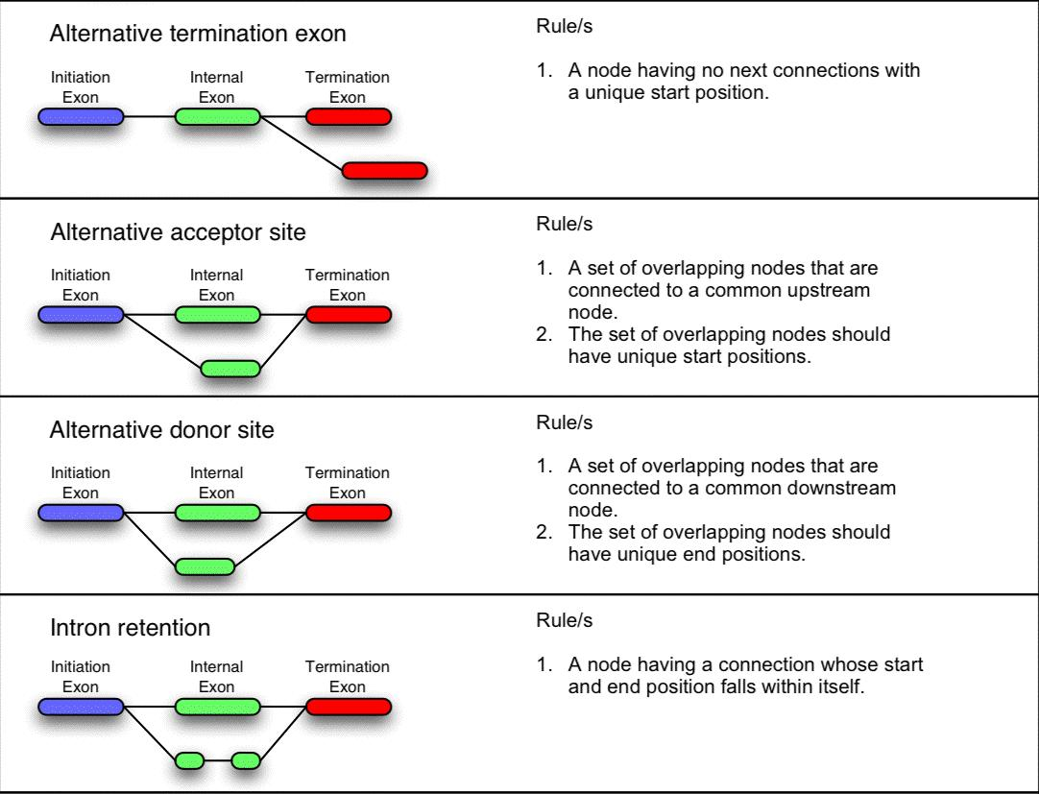
Figure 3. An excerpt of 4 out of 11 possible transcript event classifications [3].

The logic behind transcript classification was placed in the Graph API. It was the most challenging part of this project for me, as I had to ensure that each transcript was properly classified. This task occupied 4 weeks of my IT.

Upon reflection, I did not have a solid strategy to tackle the problem with. A simple event such as ‘alternative termination exon’ was easy to determine in most scenarios. However, complex events such as ‘intron retention’ were much more difficult to handle, specially when there were more than 3 alternative transcripts.

In the case of ‘intron retention’, the complexity arises as classification depends on exons overlapping in position across several alternative transcripts. I had to keep track of a permutation of overlaps without counting each permutation twice. Additionally, the event classifications were occasionally not strong enough, resulting in 2 potential classifications for 1 arrangement of exons. This constituted a special case where I had to make an arbitrary decision on where to place the transcript. The greater the number of transcripts, the greater the number of special cases it generated.

Given the tight schedule, I did not have sufficient time to characterize, test and document all special cases. I managed to complete the simple events, but not the complex ones. The results were sent to another mySQL relation called EVENT.

I suggested a systematic approach to this problem of event classification algorithm development, to solve the problem in an elegant manner, which I put across in my presentation held at the end of the IT project. The key focuses are:

- Determine an optimal sequence to traverse the exons, and to detect events
- Resolve special cases by making event classifications stronger
- Determine a tree of inter-dependence between events

JSP servlet

This JSP servlet resided on the iMac web server running Apache Tomcat JSP servlet container.. This task occupied 1 week of my IT. The JSP servlet needed to fulfill the following requirements:

- Handle web user request by specific transcript ID
- Extract relevant data from mySQL relations
- Request retrieval of unavailable graphs from web data assembler class

This computer hosts the research group’s website, and it has very high uptime. As a result of this architecture, a web user never directly accesses the MacPro, their requests were made at the iMac HTTP gateway, which was then relayed to the MacPro listening on a specific port.

I designed the workflow in such a way that most of the processing had been done before the web user request stage, to minimize latency. When the JSP servlet receives a request, all it has to do is to query the mySQL relations of GRAPH and EVENT, then retrieve and display all the relevant data in the web browser.

Originally, EBGS queries were meant to be processed dynamically, assembling all graphs and information from ENSEMBL raw data each time. This was thought to eliminate local updates and storage. However, after performing some tests, we determined that the response time and throughput was unsatisfactory, hence I had to redesign the workflow to include multiple mySQL relations to facilitate better efficiency.

Requirement #3 for the JSP servlet could not be met in time. I was not able to understand the web assembler class well enough to modify it. Thus I implemented a workaround for missing graphs in the database by writing unfulfilled queries to a text log. Manual updates could be performed by the future maintainers to keep EBGS up to date.
TRAINING

As part of my training, I was given structured mini tasks to complete before tackling the actual project. For example, when I first started work on the project, I had no knowledge of how the JDBC (Java Database Connectivity) API functioned. The overall task was as follows: Given some input files, create new PostgreSQL database relations, acquire necessary files (i.e. JDBC drivers), set environment variables, parse and store input into database tables, and finally output the fields in a dynamic JSP web page. This took 1 week.

Additionally, I was given ~20 prescribed literature references, which were important for understanding the background and biological context of the project. This took 1 week.

All other learning that took place was self-taught through the use of reference books, online tutorials, trial and error, and discussion. I reported my progress on a fortnightly basis, and I also gave a presentation at the end of my work experience. However, when I faced a major issue at any stage of the project, my supervisors were available for consultation at short notice.
IT RELEVANCE

This section you should relate the work experience you received to the studies you have completed to date, and also to the studies that you anticipate completing in the near future. You could also relate your work experience to your future career plans, and comment on whether or not you have changed your career plans as a result of your work experience.

This work experience has given me a chance to apply and appreciate all the bioinformatics skills that I have acquired in the past 4 years at UNSW. After getting a taste of academic research, I have definitely decided that it is not the road I want to take. However, I am grateful for all the skills that I have learnt and practiced over the 4 months.

STUDIES
Bioinformatics is a relatively new degree, and as a student, I have been continually informed about its significance in biology. I have struggled to comprehend its role in biological research, despite being taught many programming and biology courses. My work experience at Macquarie University has allowed me to participate in bioinformatics research in a real working environment. This has brought meaning to all the knowledge I have attained in the last 4 years.

Programming and biology are on opposite ends of the spectrum in terms of subject matter. However, they are similar in the fact that they cannot be casually learned in a short period of time. It has taken me the whole duration of my university career to acclimatize to both fields. Thus I feel that my degree has given me a head start against other graduates who wish to combine the two in their careers.

FUTURE PLANS
I feel that the UNSW Bioinformatics degree is very versatile, in that it grants an intermediate level of knowledge in diverse areas of biology, computer informatics, and experience in scientific and engineering research. Admittedly, I do feel a bit like a “jack of all trades”, and I am still undecided on which field I would like to specialize in and pursue. However, if I had known what was involved at the beginning of my university studies, I would have chosen to do something else. This is due to 2 main factors, which are relative difficulty, and slow adoption in Australia.

Inevitably, I would have to undertake some form of post graduate studies, ideally something relating to project management, as I like to work on projects that can become commercially viable. After my work experience, I am quite clear on what I do not want to work on, and that is a career in academic research, which tends to have longer-term goals. I need to see the light at the end of the tunnel, or else I will get frustrated.
CONCLUSION

I worked at the Bioinformatics Group of the Macquarie University Biotechnology Research Institute from December 2006 to March 2007. They have a well-established research laboratory, where they work on project collaborations both within and outside of the faculty.

My project was “Rule-Based Splicing Graph Bioinformatics Web Service”. I focused my efforts on several key aspects of this project, including parsing input, graph output, web user features and interface. I programmed in JDBC and JSP, and utilized object oriented programming. Throughout this time, I consistently made program documentation and kept a learning journal of challenges I faced, and how I overcame them.

As part of my training, I was given mini tasks to complete before tackling the actual project. I learnt the APIs of JDBC, JSP, and Perl that would be relevant to the mini tasks and the project, through the use of reference books, online tutorials, trial and error, and discussion with supervisors. I reported my progress on a fortnightly basis, and I gave a presentation at the end of my work experience.

This work experience has given me a chance to apply and appreciate all the bioinformatics skills that I have acquired in the past 4 years at UNSW. After getting a taste of academic research, I have definitely decided that it is not the road I want to take. However, I am grateful for all the skills that I have learnt and practiced over the 4 months.

REFERENCES

- Macquarie University Biotechnology Institute, http://biotechnology.mq.edu.au/
- MUBRI Bioinformatics Group, http://www.biolinfo.org/
- Drosophila melanogaster Exon Database, http://proline.bic.nus.edu.sg/dedb/
- ENSEMBL Genome Browser, http://www.ensembl.org/info/software/core/index.html
5. Event-based graphing service, unpublished work, Ranganathan S, Bollina D, Chang R

